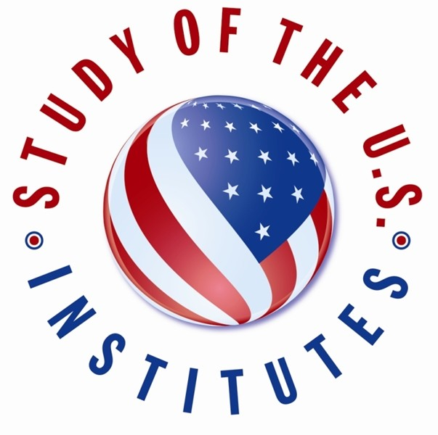

Study of the U.S. Institutes (SUSIs) for Student Leaders Nomination Form

- Required

- This form will record your name, please fill your name.

Select the SUSIs Bundle: *

Study of the U.S. Institutes' Madeleine K. Albright Young Women Leaders Program (University of Kansas)

SUSIs for Student Leaders from Europe (Meridian)

SUSIs for Student Leaders from the Western Hemisphere (Institute for Training and Development)

John McCain SUSI for Student Leaders on the Rule of Law and Public Service (University of Nevada)

SUSI for Student Leaders from Pakistan on Comparative Public Policymaking (University of Massachusetts)

SUSIs for Global Student Leaders (Meridian)

Select the Theme of the SUSI (Global Student Leaders): *

Civic Engagement - University of Washington, Seattle

Climate Change and the Environment - University of Nevada, Reno Economic Empowerment - University of Massachusetts, Amherst
Religious Diversity and Democracy - Temple University

Select the Theme of the SUSI (Student Leaders from Europe): *

Civic Engagement - Michigan State University

Environmental Issues - Host Institution to be Determined Journalism and Media - Arizona State University

Is the candidate part of an indigenous or Afro-Latina community? *

Yes No

If you answered "no" to the previous question regarding the candidate's indigenous or Afro-Latina ethnicity, please explain below. *

- Select the Theme of the SUSI (Student Leaders from the Western Hemisphere): *

Civic Engagement - Institute for Training and Development

Entrepreneurship and Economic Development - Miami University of Ohio

Women's Leadership for Indigenous and Afro-Latina Women - University of Arizona, Tucson

Winter - Entrepreneurship and Economic Development - Institute for Training and Development

Winter - Women's Leadership for Indigenous and Afro-Latina Women - University of Arizona, Tucson

Select the Theme of the SUSI (Albright Young Women Leaders Program) *

Public Policy -University of Kansas

Economic Empowerment - University of Delaware Civic Engagement - Saint Mary's College
Environmental Issues - Green River College

Does the candidate demonstrate evidence of English fluency?

Yes No

Is this a Principal or Alternate Candidate? *

Principal Candidate Alternate Candidate

Candidate Rank: *

1

2

3

4

5

6

7

8

9

10

11

12

13

14

15

16

17

18

19

20

CANDIDATE ELIGIBILITY:

Please confirm that the candidate meets the following eligibility criteria:
interest in the Institute theme;

between 18 and 25 years of age at the time of the Institute;
have at least one semester left of their undergraduate studies after their completion of the Institute (example: If the Institute takes

place in the summer, the participant should be enrolled for the fall semester following the program);
is not an employee or immediate family member of employees of

the U.S. Government (including a U.S. Embassy or Consulate, USAID, or other U.S. Government entity) or Fulbright commission.

*

Yes No
Other

SECTION A: CANDIDATE INFORMATION
Please provide information exactly as it appears in the candidate's passport.

Surname (Last Name): *

- Given Name(s): *

Gender: *

Female Male
Non-binary Other

Date of Birth: *

- City of Birth: *

Country of Birth: *

- Primary Citizenship: *

Country of Residence: *

- Secondary Citizenship (if applicable):

Candidate Contact Information:

Street Address: *

- City: *

State/Province:

- Postal Code:

Country: *

- Phone Number: *

- Email Address: *

Medical, Physical, Dietary, or other Personal Considerations:
This will not affect a candidate's selection, but it will enable the host institution to make any necessary accommodations

Please indicate if the candidate has a disability. *

None

Blind or Visual Impairments Deaf or Hearing Impairments Learning Disability
Physical Disability Psychiatric Disability Systemic Disability
Other

- Please describe any pre-existing medical conditions, prescription medication, dietary restrictions, or personal considerations for the candidate.

Experience in the United States:

Has the applicant traveled to the United States before? *

Yes No

If yes, please list any previous travel to the United States for the purposes of tourism/vacation, conferences, educational study, or previous ECA
programs. Provide dates/duration, purpose of visit(s), and location(s). (Examples: July 4-14, 2019 - Tourism to Washington, D.C.; December 1- 15, 2018 - Short Term Study Abroad to New York City, NY).

Has the applicant previously participated in or been accepted into another U.S. Department of State sponsored program? *

Yes No

If yes, please provide the name of the program and the dates. *

- Family Residing in the United States (if applicable):
Please include name, relationship to candidate, city, and state. (Example: Jane Doe, sister, Denver, CO).

SECTION B: CANDIDATE BACKGROUND

Year in School: *

First-Year Student Completed First Year
Completed Second Year Completed Third Year Completed Fourth Year Part-Time Student
Postgraduate Student

Expected Date of Graduation: *

- Will the candidate have one semester left in their studies after the completion of the SUSI program? *

Yes No
Other

Major/Field of Study: *

- University: *

Country of University: *

- Work History:
Please include employer, position, dates, and location.

Volunteer Experience:
Please include organization, dates, and location.

Memberships in Associations, Clubs, etc.:
Please include organization and dates.

Candidate Personal Statement: *
As part of the SUSI application process, candidates should submit a personal statement about their background and goals. In up to 500 words, the candidate should address the following questions and any other pertinent information:
What about your background and interests makes you competitive for the SUSI program?
What will you contribute to the program?
How will your participation in the SUSI program affect your local community, region, or country?
How will the SUSI exchange affect you personally or professionally?

Please input the candidate's personal statement below.

SECTION C: COMPLETED BY POST

Statement by Post Justifying Participation of Nominee in the Institute: *
This is one of the most important components of the nomination and we kindly ask you to provide a substantive answer. (Please note the online form supports up to 4,000 characters, including spaces.) After having interviewed the candidate, please address the following questions in your statement:
Can you please tell us about this individual and why Post feels that they are well suited for the Institute?
What makes this candidate unique?
What, in particular, will this candidate contribute to the Institute and upon their return home?
Why is this a priority nomination for Post?

- How many applications did Post receive for this particular Institute? *

Post Contact Information:
The person whom the Study of the U.S. Branch should contact with all inquiries about the nomination.

U.S. Embassy or Consulate: *

- Post Country: *

Post Region *

AF EAP EUR NEA SCA
WHA

Post Contact Name: *

- Post Contact Email: *

Backup Contact Name: *

- Backup Contact Email: *

This content is neither created nor endorsed by Microsoft. The data you submit will be sent to the form owner.
Microsoft Forms

